Netflix Content Analysis Report
Aneesh Fathima
Date – 07-06-2026
Executive Summary:
The Netflix Content Analysis Project was developed to examine the distribution and characteristics of content available on the Netflix platform. The primary purpose of this analysis is to understand content trends, genre popularity, country-wise content production, release patterns, and content ratings, thereby providing meaningful insights into Netflix’s content library. The dataset contains information related to content type, title, director, cast, country, release year, date added, duration, genre, rating, and description. By applying data cleaning, exploratory data analysis, and visualization techniques using python, the project transforms raw data into valuable insights that support a better understanding of Netflix’s content distributions and trends.
Table of Contents:
- Introduction
- Methodology
- Key Findings & Recommendations
- Conclusion
Introduction
This project focuses on analyzing the Netflix content dataset using Python, Pandas, Matplotlib, and Seaborn to explore content distribution and trends. The objective is to generate meaningful insights into Netflix’s content library through data cleaning, exploratory data analysis, and visualization.
Methodology
To conduct the data analysis, a systematic approach was followed to ensure accuracy and reliability in the findings. The methodology encompassed the following steps:
- Data Collection: Sales data from the designated time period was collected from https://www.kaggle.com/, including item details, total sales amount, Customer ratings, etc…
- Data Preprocessing: Before analysis, the dataset was cleaned and pre-processed to improve data quality and ensure accurate analysis. Missing were handled appropriately.
- Exploratory Data Analysis (EDA): Exploratory Data Analysis was performed to identify important patterns and trends in the dataset. Various visualizations were created to analyze product sales, customer ratings, outlet performance.
- Reporting: The findings, insights, and recommendations were compiled into a comprehensive data analysis report. The report presented the analysis results in a clear and organised manner using visualisations, tables, and concise explanations.
Key Findings & Recommendations
The analysis of the Netflix dataset addresses key business questions related to content distribution, genres, ratings, countries, and release trends. The key findings and recommendations are as follows:
- Netflix Content by Type:
The analysis shows that movies dominate Netflix’s content library, with significantly more movie titles than TV shows.
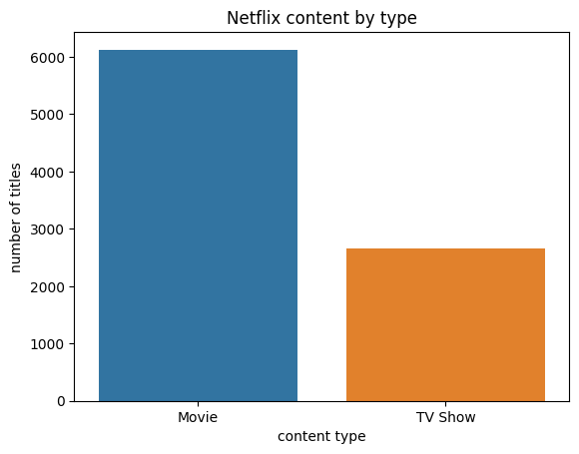
- Top 10 Countries by Netflix Content:
The analysis indicates that United States has the largest Netflix Content library, followed by India. Other major content-producing countries include the United Kingdom, Japan, South Korea, Canada, Spain, France, and Mexico, demonstrating Netflix’s strong presence across multiple regions.
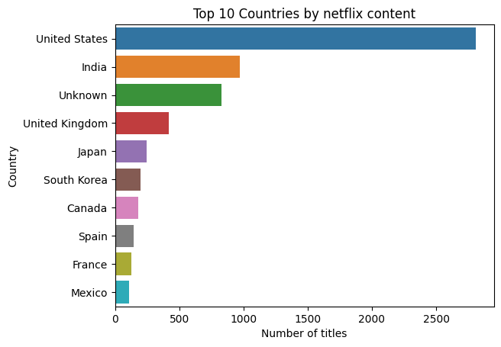

- Top 10 Netflix Genres:
The analysis shows that dramas are the most common genre on Netflix, followed by comedies and action & adventure. Documentaries, international TV shows, childre’s and family movies, crime TV shows, kids ‘TV, stand-up comedy, and horror movies also make up a significant portion of Netflix’s content library, reflecting a diverse range of entertainment for different audience.
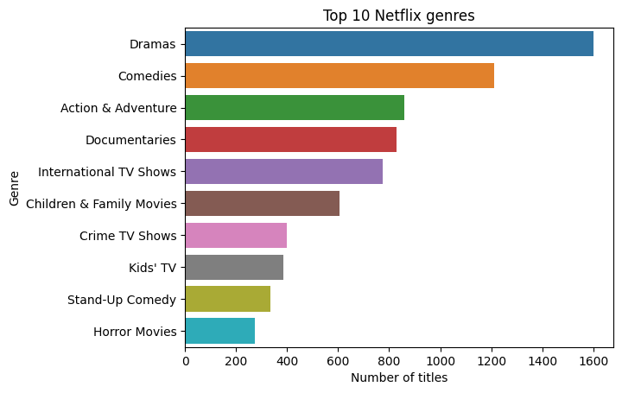
- Netflix Content over the years:
The analysis indicates that most Netflix content was released between 2000 and 2020, with a noticeable increase in titles during this period.
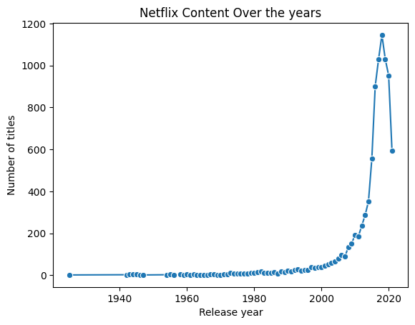
- Distribution of content ratings
The analysis shows that TV-MA is the most common content rating on Netflix, followed by TV-14 and TV-PG. Ratings such as R, PG-13, TV-Y7, TV-Y, PG, TV-G, NR, and G are also represented, indicating that Netflix offers content suitable for a wide range of audience age groups.
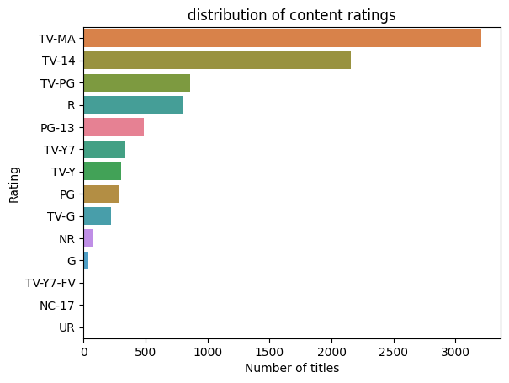
- Top 10 directors on Netflix
The analysis identifies Rajiv Chilaka as the director with the highest number of titles on Netflix, followed by Rahul Kamboj, Jan Suter, Suhas Kadav, Marcus Raboy, Jay Karas, Cathy Garcia-Molina, Youssef Chihine, Martin Scorsese, Jay Chapman, and Steven Spielberg. This indicates that these directors have made the most significant contributions to Netflix’s content library based on the number of available titles.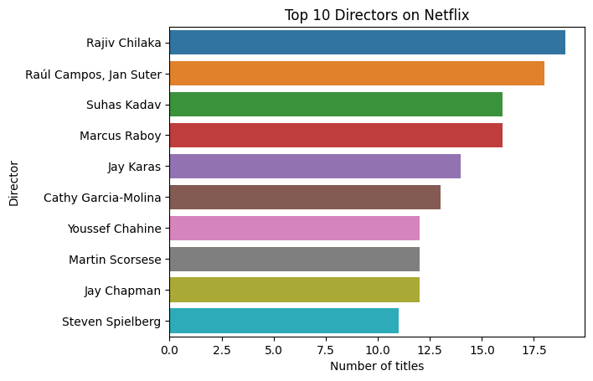

- Top 10 most featured actors:
The analysis shows that Anupam Kher is the most frequently featured actor on Netflix, followed by Shah Rukh Khan, Juli Chawla, Naseeruddin Shah, Takahiro Sakurai, Rupa Bhimani, Akshay Kumar, Om Puri, Yuki Kaji, and Amitabh Bachchan. This indicates that these actors appear most often in the Netflix content included in the dataset.
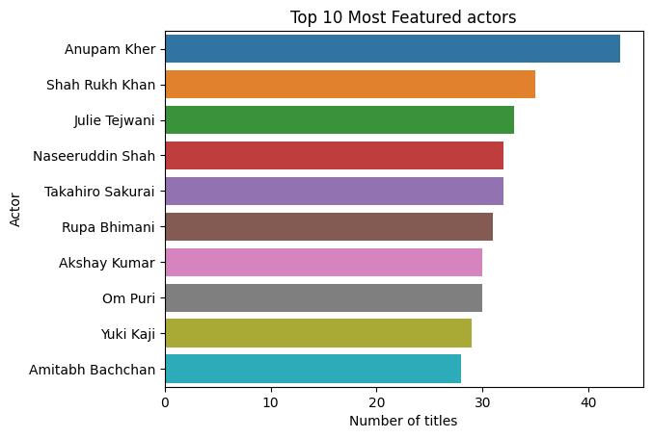
- Distribution of movie duration
The analysis shows that most Netflix movies have a duration between 75 and 125 minutes, with around 100 minutes being the most common. This indicates that Netflix primarily features standard-length movies that align with typical audience viewing preferences.
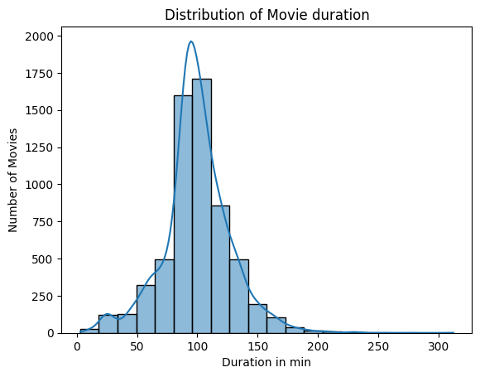

- Netflix releases by year:
The analysis shows that Netflix content releases increased steadily from 2010 onwards, with the highest number of titles released between 2017 and 2019. This indicates a period of rapid content expansion, during which Netflix significantly grew its content library.
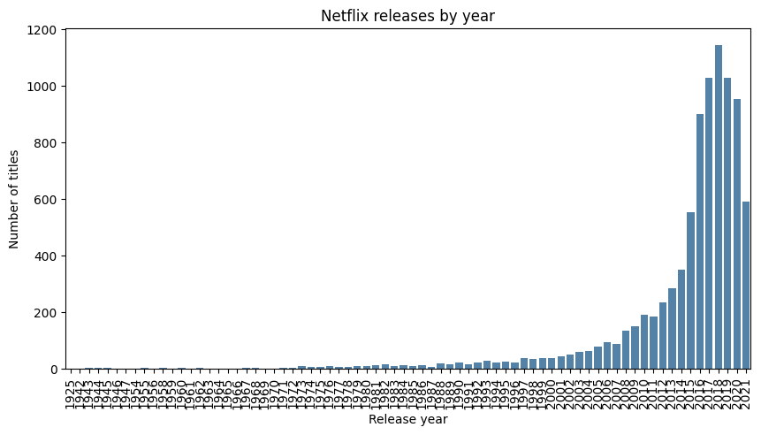
- Movies vs TV shows in Top 10 Countries:
The analysis shows that the United States and India have a significantly higher number of movies than TV Shows, while the United Kingdom has a more balanced distribution of both content types. In contrast, South Korea and Japan features relatively more TV shows, whereas most other top countries primarily contribute movies to Netflix’s content library.
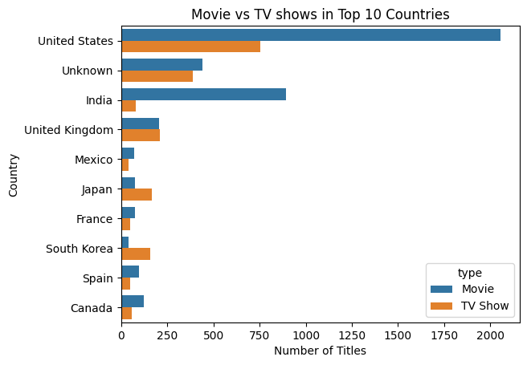
The Netflix content analysis identified key patterns in Netflix’s content library through data cleaning, exploratory data analysis, and visualization. The analysis revealed that movies dominate the platform, the United States and India contribute the largest share of content, dramas and comedies are the most common genres, and content production increased significantly between 2010 and 2019. It also highlighted the most frequent directors and actors, common movie durations, popular content ratings, and differences in movie and TV show distribution across major countries. Overall, the project demonstrates how data analysis can transform raw streaming data into meaningful insights that support a better understanding of content trends and distribution.
Conclusion:
Netflix content analysis demonstrates how exploratory data analysis can be used to uncover meaningful insights from a large content dataset. The findings provide a better understanding of content trends and can support informed decisions related to content strategy, audience preferences, and future planning.

